## Report No.6: System User’s Manual

##### 6.1. Installation Guide

6.1.1 System requirements

* Operation system: Windows 7 (32 or 64 bit) or laster
* Memory: 2G RAM or more
* Browser: Firefox v25 or laster
* IIS feature is turned on

6.1.2 Installation

6.1.2.1 Deploy Database

* Run script file “~/FootballPitchesBooking/Database/FootballPitchesBooking.sql” in SQL Server Management Studio.

6.1.2.2 Deploy Application

* Open “Internet information Services (IIS) Manager”.
* Right click on “Sites” folder in left content, select “Add Web Site”.

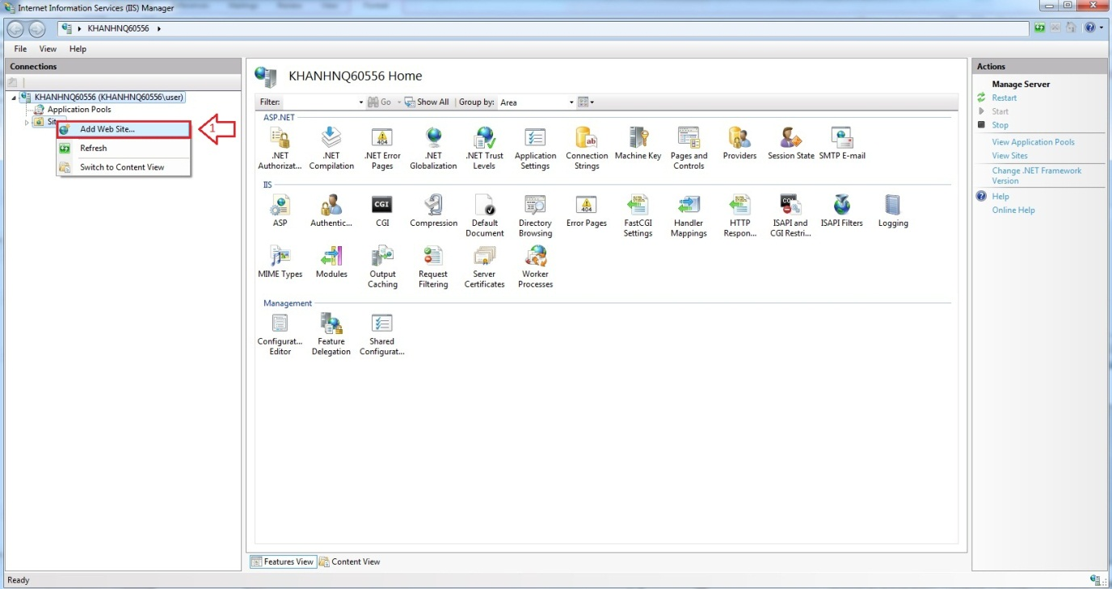

Firgure 6.1 Add Web Site

* Enter “Site Name”.
* Click on “Select” button to select Application pool.

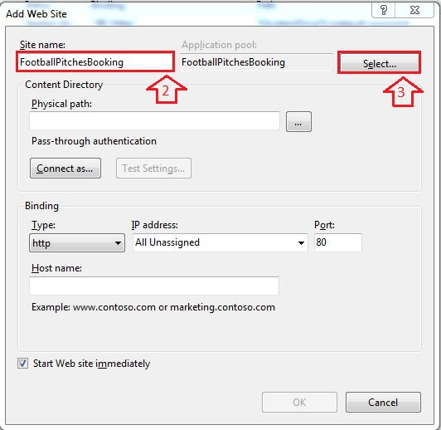

Figure 6.2 Add Site Name

* Select “ASP.NET v4.0”.

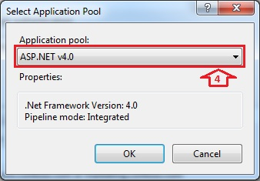

Figure 6.3 Select ASP.NET

* Browse physical path: “~/ FootballPitchesBooking”.

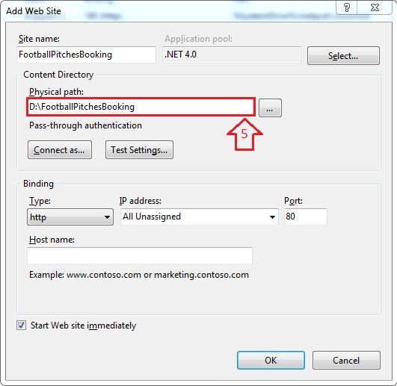

Figure 6.4 Add Path Link

* Open “~/ FootballPitchesBookingProject/Web.config” file by Notepad.

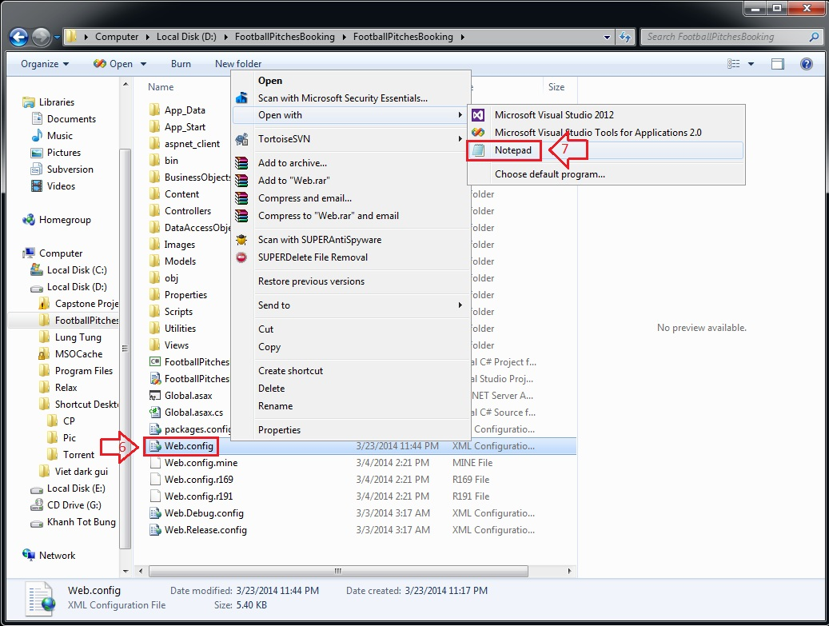

Figure 6.5 Edit Web.config

* Find “connectionStrings” tag, change “Server Name”, “User ID” and “Password” in its connection string depend on your computer.

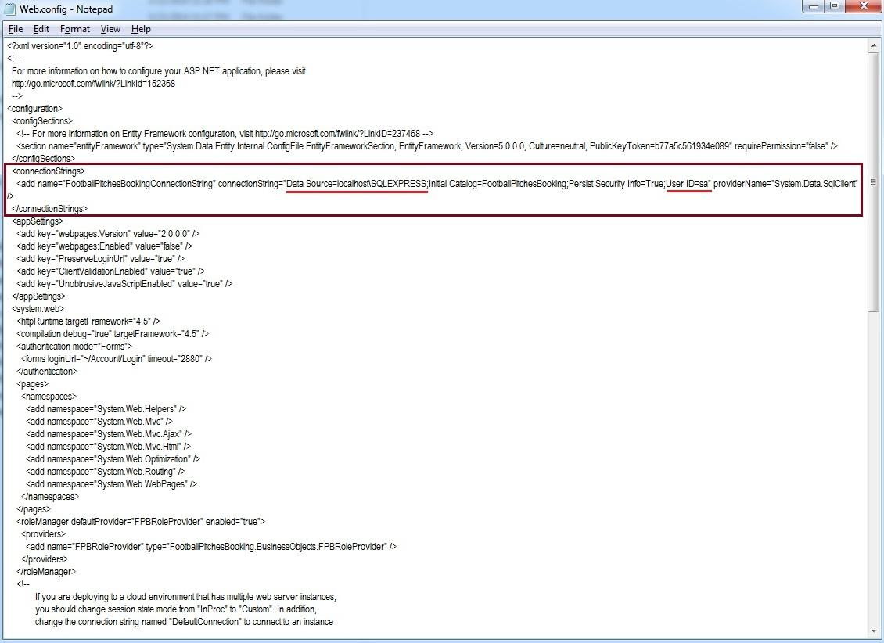

Figure 6.6 Edit Web.config

* Right click on new site name (FootballPitchesBooking) in left content -> Manage Web Site -> Browse to view the website.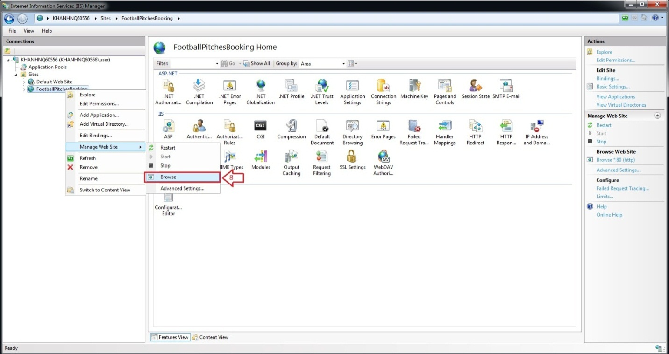

Figure 6.7 How to open Website

* The website is deployed.

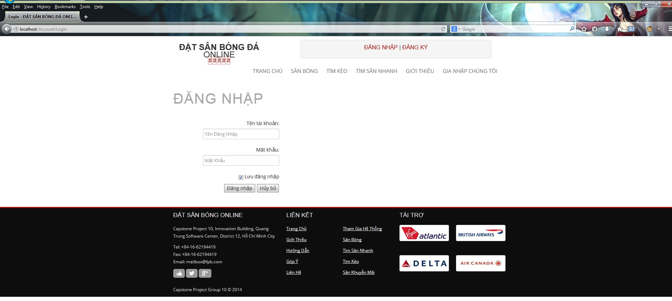

Figure 6.8 Website is deployed

##### 6.2. User’s Guide

6.2.1. Website Master

- Step 1 : Login with WebsiteMaster role

- Step 2 : Click on “Quản Trị Website” link in Admin page

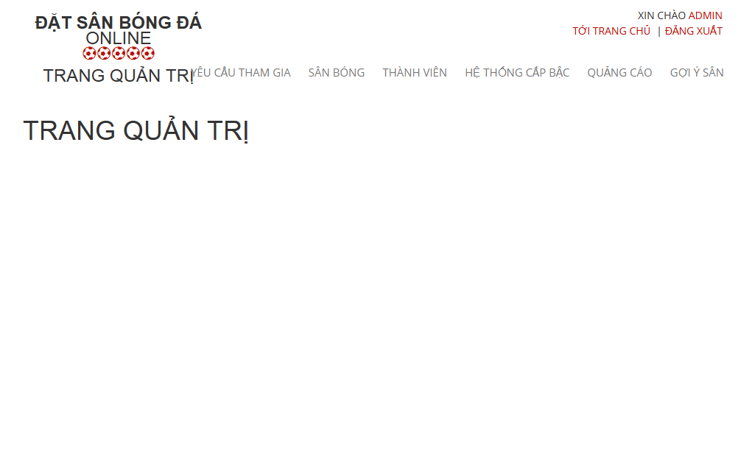

Figure 6.9 Website Staff

6.2.1.1. Join Request Management

6.2.1.1.1 View All Join Request

- Step 1 : Click on “ Yêu Cầu Tham Gia “ link to view all join request from member

6.2.1.2. Stadium Management

6.2.1.2.1 View All Stadiums

- Step 1 : Click on “ Sân Bóng “ link to view all stadiums

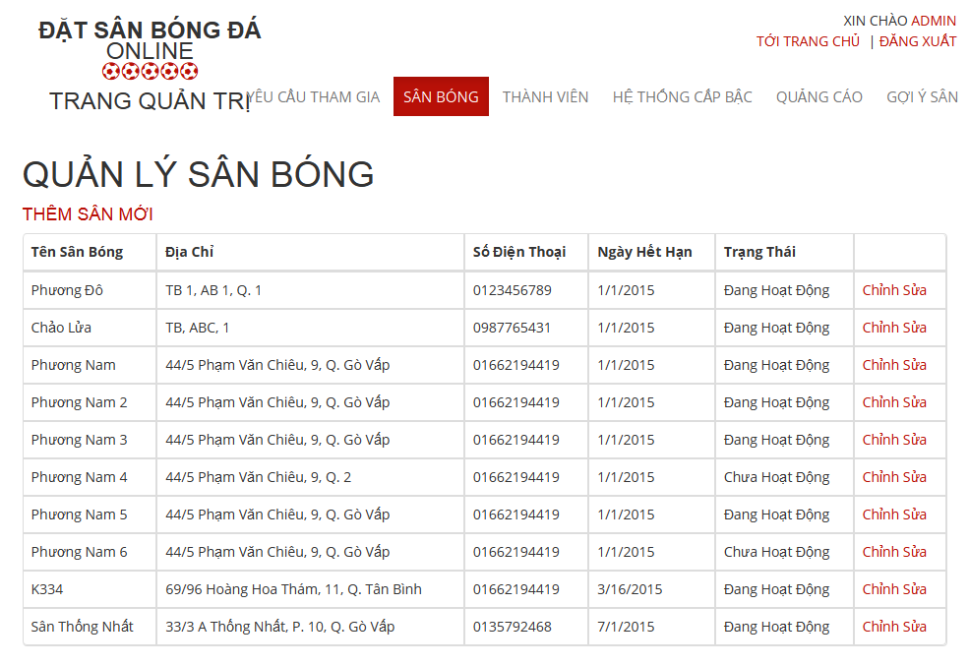

Figure 6.10 View All Stadiums

6.2.1.2.2 Add New Stadium

- Step 1 : Click on “ Thêm Sân Mới “ link

- Step 2 : Input all required fields

- Step 3 : Click on“ Thêm Sân Mới” button to add new stadium or click “ Hủy Bỏ “ button to cancel

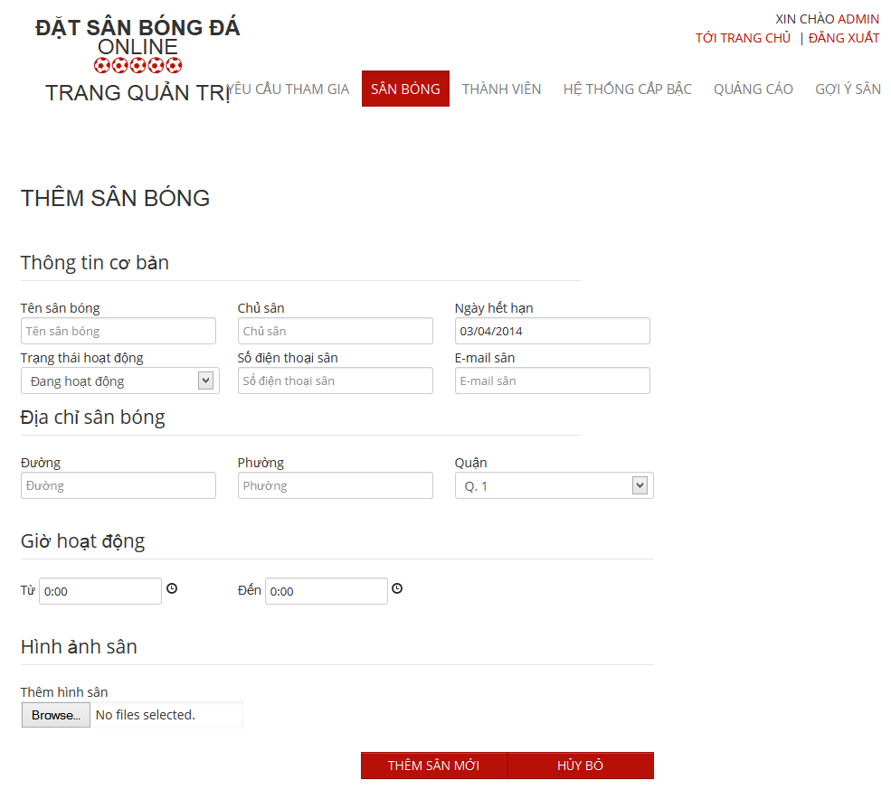

Figure 6.11 Add New Stadium

6.2.1.2.3 Edit Stadium

- Step 1 : Click on “ Chỉnh Sửa “ link

- Step 2 : Change information of field which you want to change

- Step 3 : : Click on“ Cập Nhật” button to save the information of member or click “ Hủy Bỏ “ button to cancel

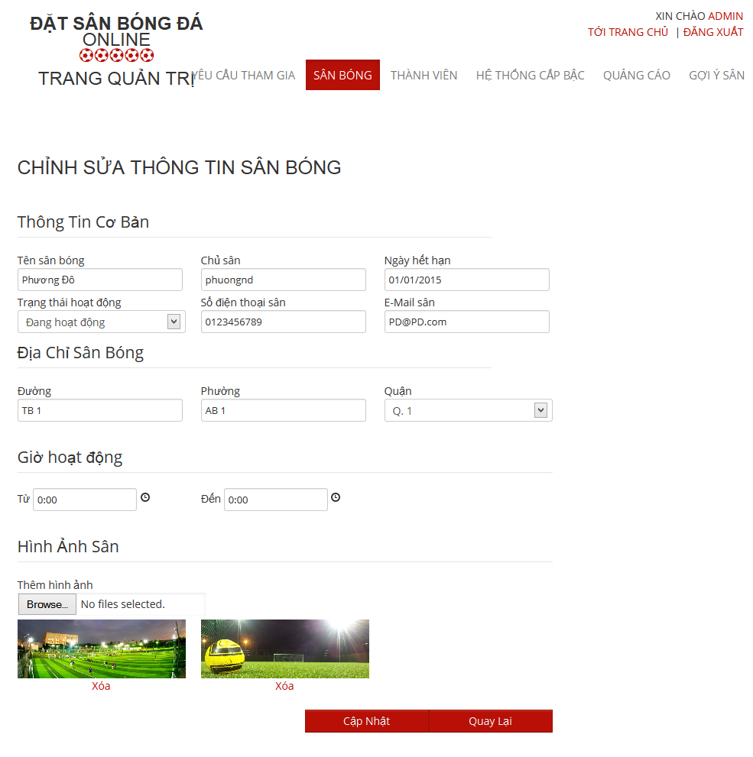

Figure 6.12 Edit Stadium

6.2.1.3. User Management

6.2.1.3.1 View List Members

- Step 2: Choose “ Thành Viên “ link to view all members of the website

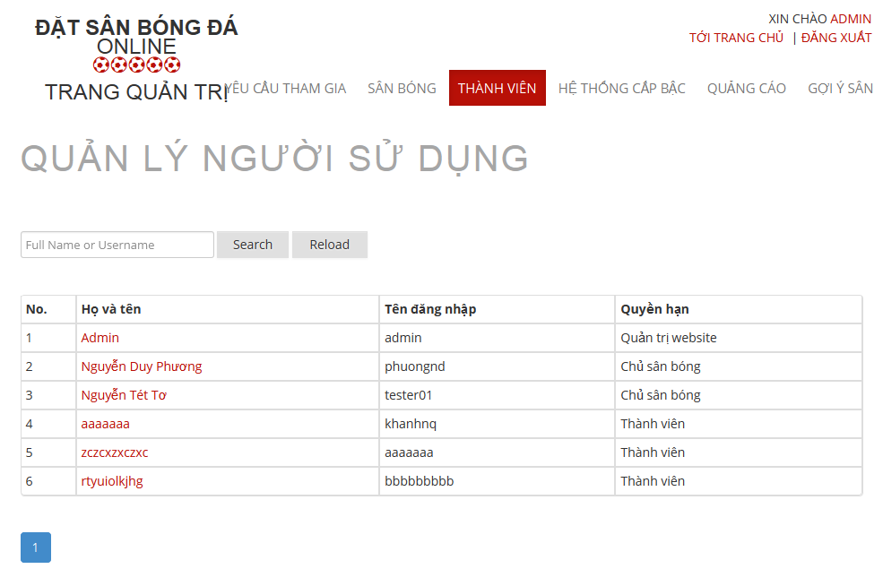

Figure 6.13 View Add Users

6.2.1.3.2 Search Members

- Step 1 : Click on the textbox beside Search Button in “ Quản Lý Người Sử Dụng “ page

- Step 2 : Input name of member you want to find

- Step 3 : Click on“ Tìm Kiếm “ button to find

- Step 4 : Click on“ Làm Mới “ to refresh member list.

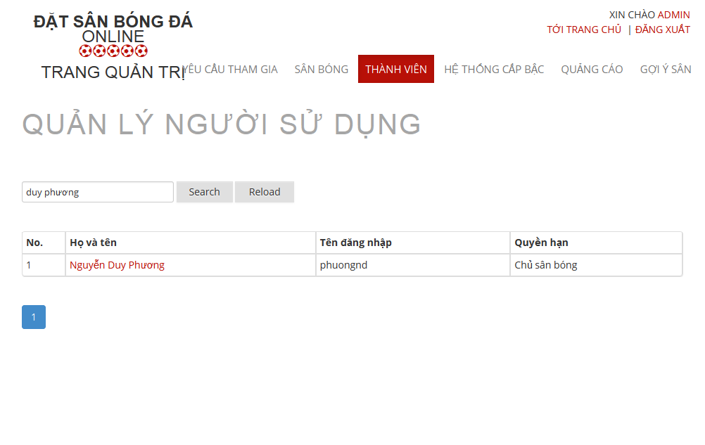

Figure 6.14 Search User

6.2.1.3.3 Edit Members

- Step 1 : Click on name of the member you want to change information

- Step 2 : Change information of field which you want to change

- Step 3 : Click on “ Cập Nhật” button to save the information of member or click “ Hủy Bỏ “ button to cancel

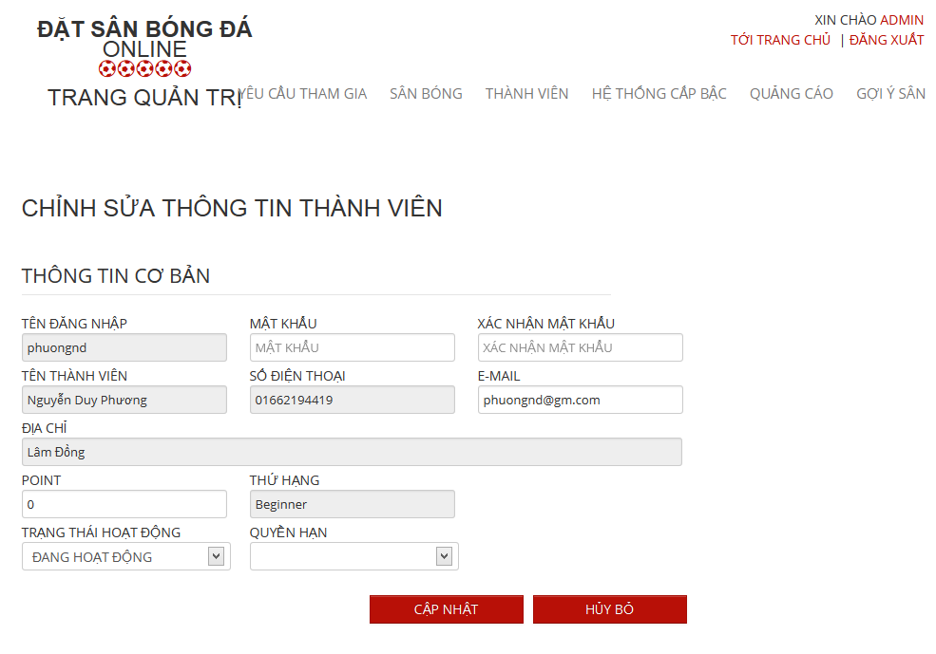

Figure 6.15 Edit User

6.2.1.4. Advertise Management

6.2.1.4.1 View All Advertises

- Step 1 : Click on “ Quảng Cáo “ link to view all advertises

6.2.1.4.2 Add New Advertises

- Step 1 : Click on “ Thêm Quảng Cáo “ button in “ Quảng Cáo “ page

- Step 2: Input in all required fields

- Step 3: Click on “ Lưu” button to add new advertise or click “ Hủy Bỏ “ button to cancel

6.2.1.5. Member Rank Management

6.2.1.5.1 View List Ranks

- Step 1: Choose “ Hệ Thống Cấp Bậc “ link to view all memberranks of the website

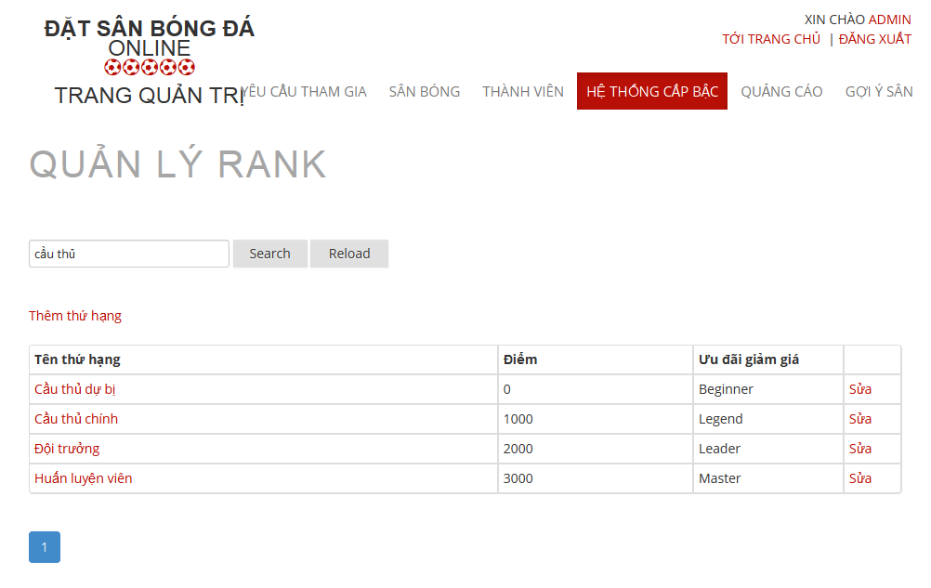

Figure 6.16 View All RankMembers

6.2.1.5.2 Search RankMembers

- Step 1 : Click on the textbox beside Search Button in “ Hệ Thống Cấp Bậc “ page

- Step 2 : Input name of memberrank you want to find

- Step 3 : Click on“ Tìm Kiếm “ button to find

- Step 4 : Click on“ Làm Mới “ to refresh memberrank list.

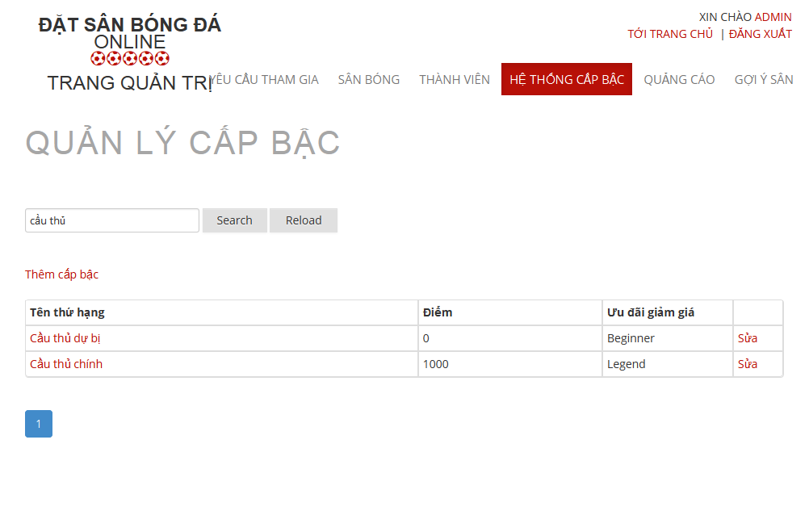

Figure 6.17 Search MemberRank

6.2.1.5.3 Add Rank

- Step 1 : Click on “ Thêm Thứ Hạng “ link in “ Hệ Thống Cấp Bậc “ page

- Step 2: Input in all required fields

- Step 3: Click on “ Lưu” button to add new memberrank or click “ Hủy Bỏ “ button to cancel

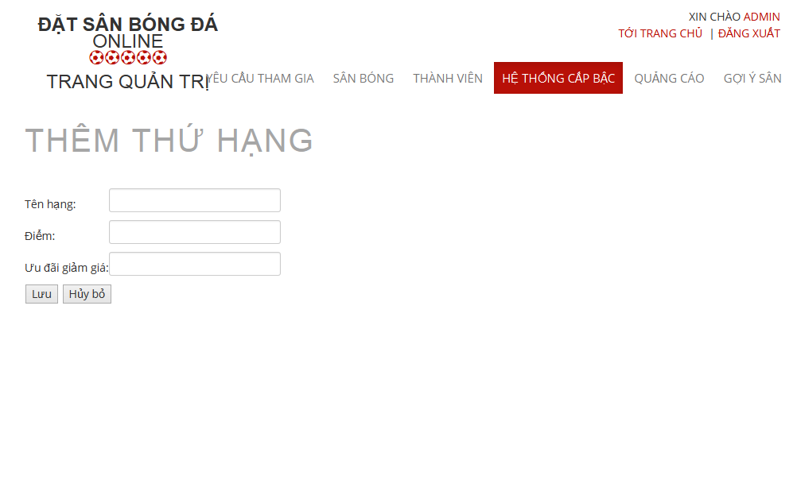

Figure 6.18 Add MemberRank

6.2.1.5.4 Edit Rank

- Step 1 : Click on “ Sửa “ link in each of memberrank in “ Hệ Thống Cấp Bậc “ page

- Step 2 : Change information which field you want to change result

- Step 3: Click on “ Lưu” button to save the memberrank or click “ Hủy Bỏ “ button to cancel

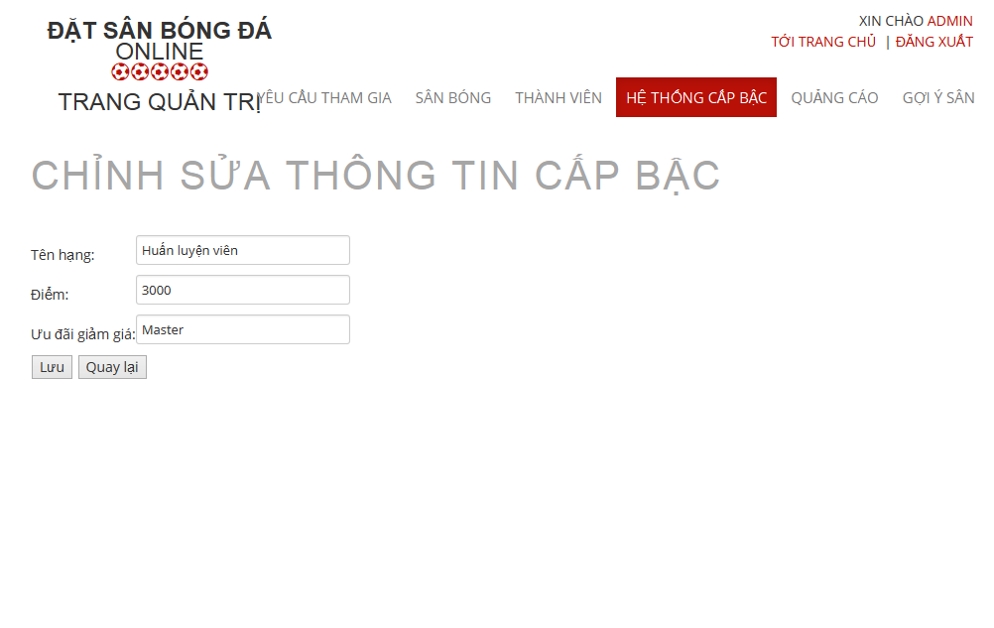

Figure 6.19 Edit MemberRank

6.2.1.6 Recommendation Management

6.2.1.6.1 View Recommendation Management Page

- Step 1 : Click on “ Gợi Ý Sân “ link

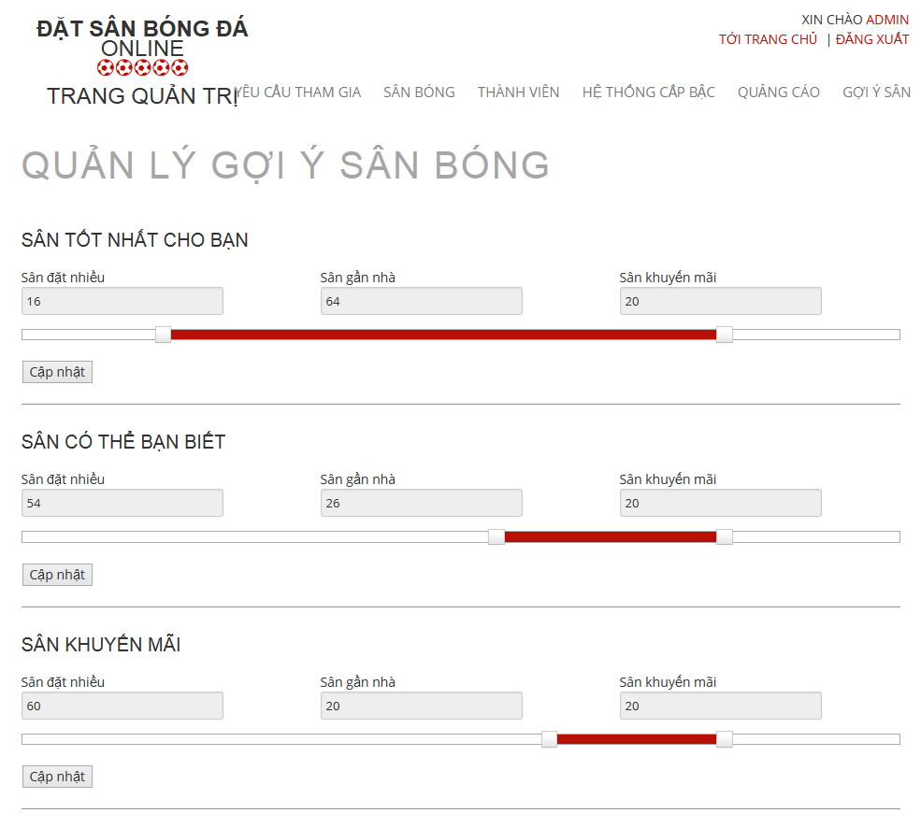

Figure 6.20 Recommendation Management

6.2.1.6.2 Edit in Recommendation Management Page

- Step 1 : Drag on the point to change the value of each priority

- Step 2 : Click on “ Cập Nhật “ button to save

6.2.2 Website Staff

- Step 1 : Login with WebsiteStaff role

- Step 2 : Click on “Quản Trị Website” link

6.2.2.1. User Management

6.2.2.1.1 View List Members

- Step 2: Choose “ Thành Viên “ link to view all members of the website



Figure 6.13 View Add Users

6.2.2.1.2 Search Members

- Step 1 : Click on the textbox beside Search Button in “ Quản Lý Người Sử Dụng “ page

- Step 2 : Input name of member you want to find

- Step 3 : Click on“ Tìm Kiếm “ button to find

- Step 4 : Click on“ Làm Mới “ to refresh member list.



Figure 6.14 Search User

6.2.2.1.3 Edit Members

- Step 1 : Click on name of the member you want to change information

- Step 2 : Change information of field which you want to change

- Step 3 : Click on “ Cập Nhật” button to save the information of member or click “ Hủy Bỏ “ button to cancel



Figure 6.15 Edit User

6.2.3 Stadium Staff

- Step 1 : Login with Stadium Staff role

- Step 2 : Click on “Quản Lý Sân Bóng ” link

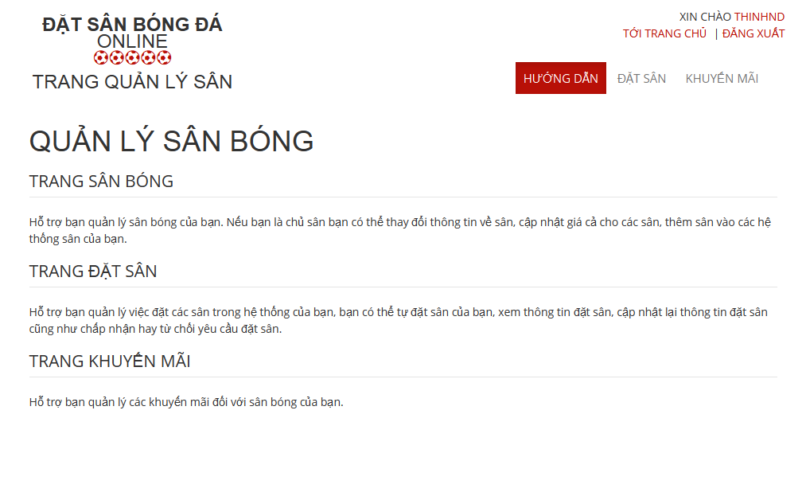

6.2.3.1 Stadium Management

6.2.3.2 Field Management

6.2.3.3 Promotion Management

6.2.3.3.1. View List Promotions

- Step 1: Click on “Khuyến mãi” link in Stadium Management page

- Step 2: Choose Stadium to view promotions of that stadium

6.2.2.3.2. Add New Promotion

- Step 1: Click on “Thêm khuyến mãi” button from Promotion Management page

- Step 2: Input information about promotion

- Step 3: Click on “Lưu” button to save or click “Quay Lại” to cancel

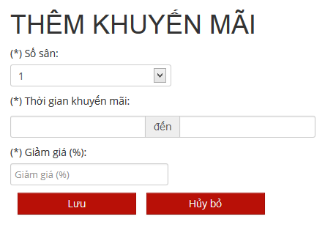

6.2.3.3.3. Edit Promotion

- Step 1: Click on “Chỉnh sửa” link on which promotion you want to edit

- Step 2: Change information about that promotion

- Step 3: Click on “Lưu” button to save or click “Quay Lại” to cancel

6.2.3.4 Reservation Management

6.2.4 Stadium Owner

- Step 1 : Login with StadiumOwner role

- Step 2 : Click on “Quản Trị Sân Bóng” link

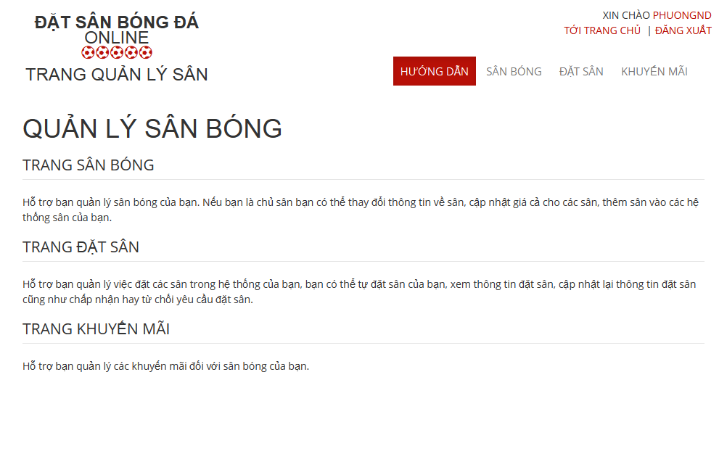

6.2.4.1 Stadium Management

6.2.4.1.1 View All Stadiums

-Step 1 : Click on “ Sân Bóng “ link

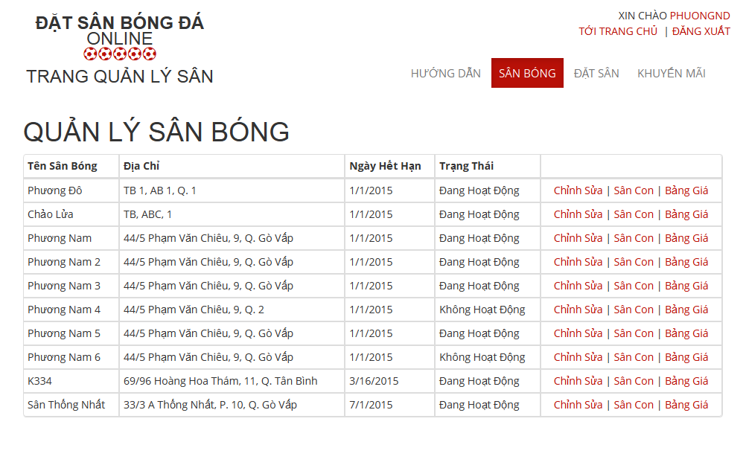

6.2.4.1.2 Edit Stadium

- Step 1 : Click on “ Chỉnh sửa “ link of the stadium which you want to change

- Step 2 : Change information of field which you want to change

- Step 3 : Click on “ Chọn Hình Ảnh “ button to choose new image about this stadium

- Step 4 : Click on “Cập Nhật” button to save or click “Quay Lại” to cancel

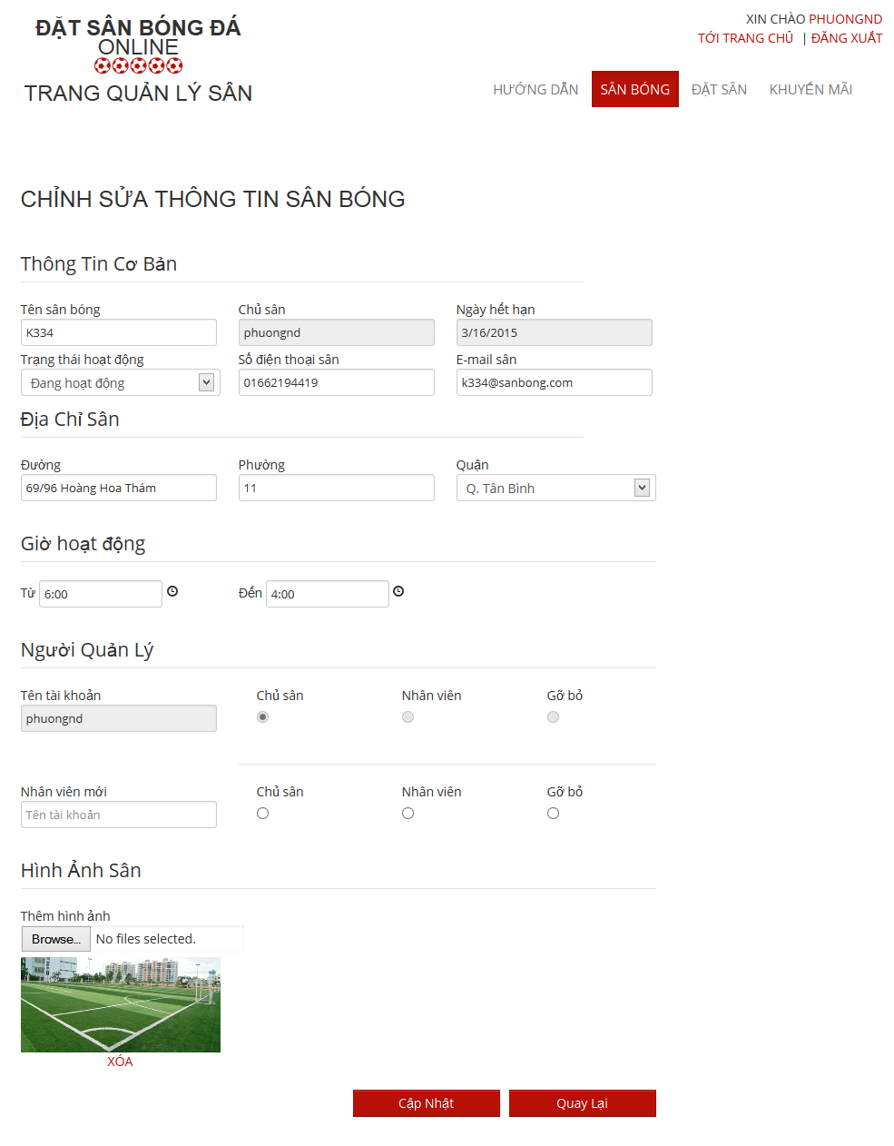

6.2.4.1.3 View Child Field

- Step 1 : Click on “ Sân Con “ link to see all child fields of this stadium

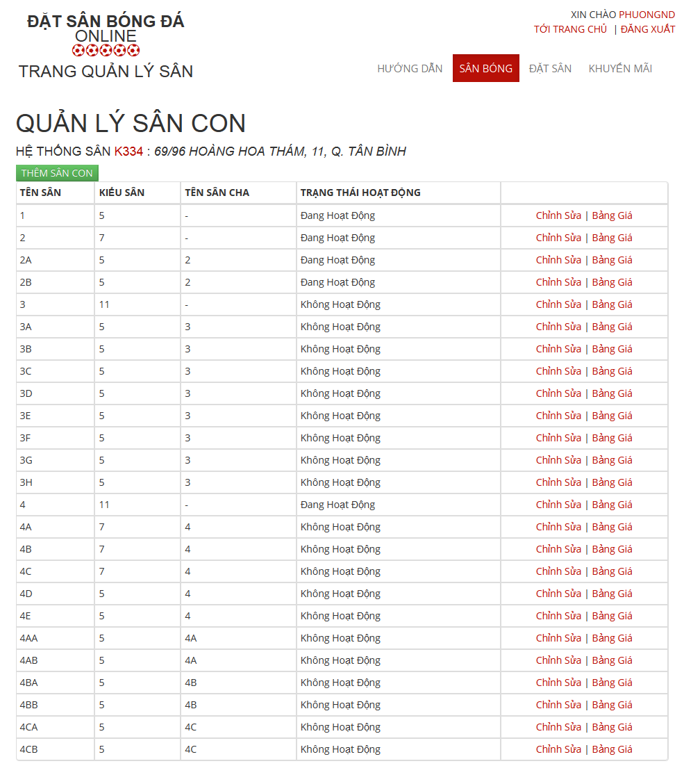

6.2.4.1.3.1 Add New Child Field

- Step 1 : Click on “ Thêm Sân Con “ button in “ Quản Lý Sân Con “ Page

- Step 2: Input in all required fields

- Step 3: Click on “ Lưu” button to add new child field or click “ Hủy Bỏ “ button to cancel

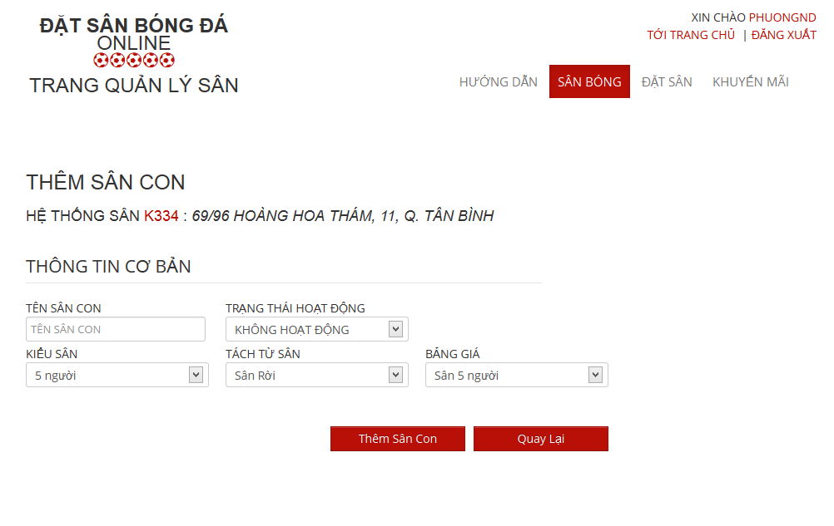

6.2.4.1.3.2 Edit Child Field

- Step 1 : Click on “ Chỉnh sửa “ link of the child field which you want to change

- Step 2 : Change information of field which you want to change

- Step 3 : Click on “Cập Nhật” button to save or click “Quay Lại” to cancel

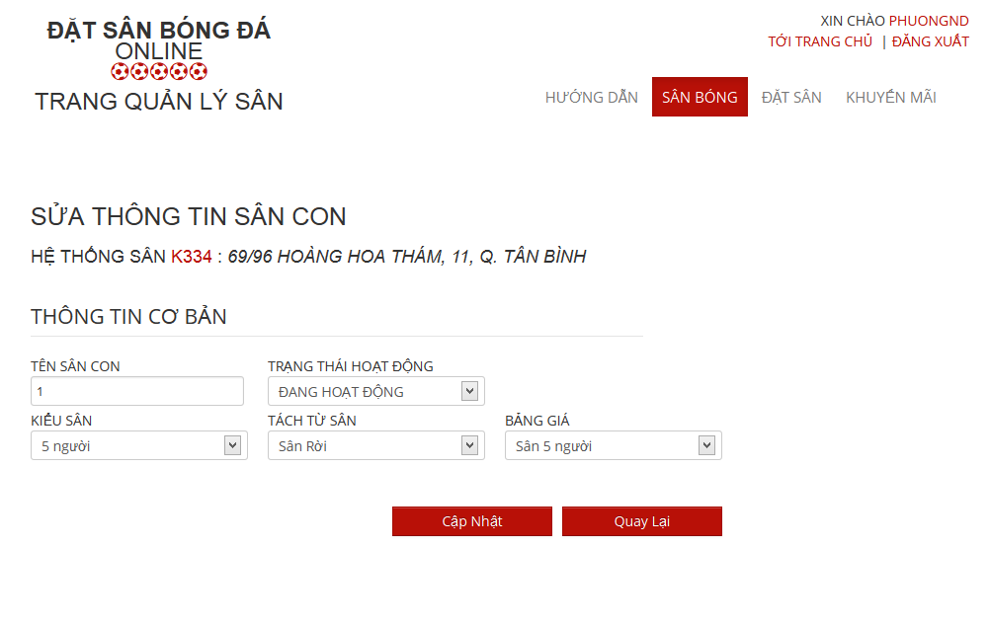

6.2.4.1.3.3 View Price List of Child Filed

- Step 1 : Click on “ Bảng Giá “ link of the child field which you want to see

6.2.4.1.4 View Price List

- Step 1 : Click on “ Bảng Giá “ link to see all child fields of this stadium

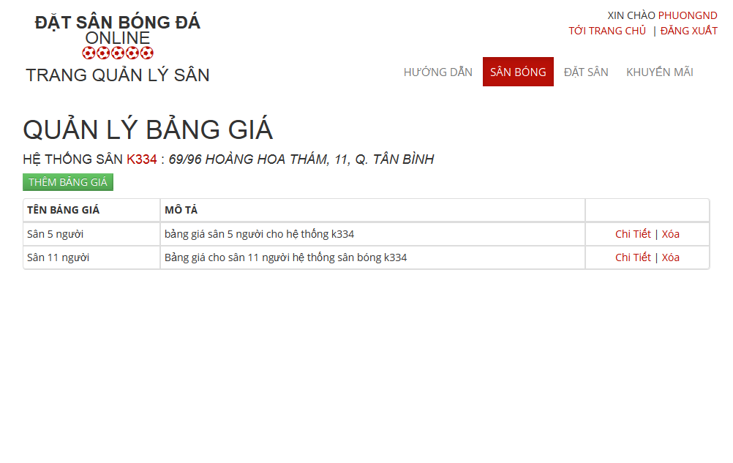

6.2.4.1.4.1 Add New Price List

- Step 1 : Click on “ Thêm Bảng Giá “ button in “ Quản Lý Bảng Giá“ Page

- Step 2: Input in all required fields

- Step 3: Click on “ Lưu” button to add new price list or click “ Hủy Bỏ “ button to cancel

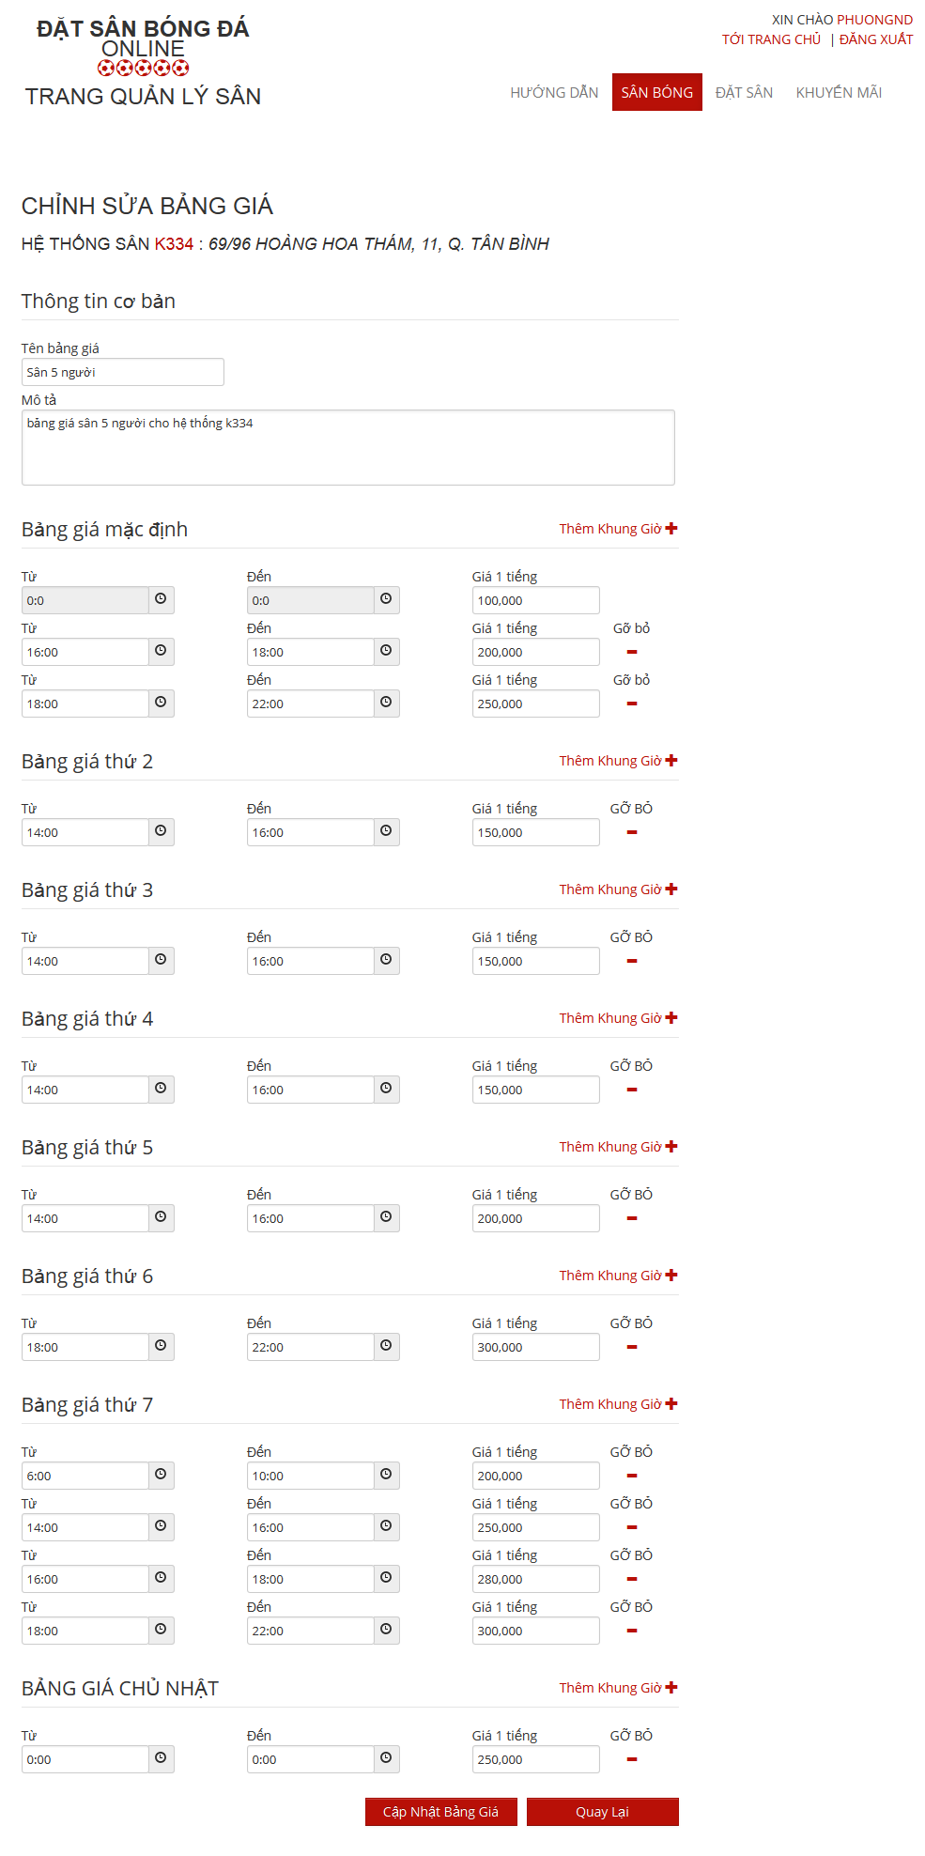

6.2.4.2 Promotion Management

6.2.4.2.1. View List Promotions

- Step 1: Click on “Khuyến mãi” link in Stadium Management page

- Step 2: Choose Stadium to view promotions of that stadium

6.2.4.2.2. Add New Promotion

- Step 1: Click on “Thêm khuyến mãi” button from Promotion Management page

- Step 2: Input information about promotion

- Step 3: Click on “Lưu” button to save or click “Quay Lại” to cancel



6.2.4.2.3. Edit Promotion

- Step 1: Click on “Chỉnh sửa” link on which promotion you want to edit

- Step 2: Change information about that promotion

- Step 3: Click on “Lưu” button to save or click “Quay Lại” to cancel

6.2.4.3 Reservation Management

6.2.4.3.1 View All Reservations :

- Step 1 : Click on “ Đặt Sân “ link to view all reservations

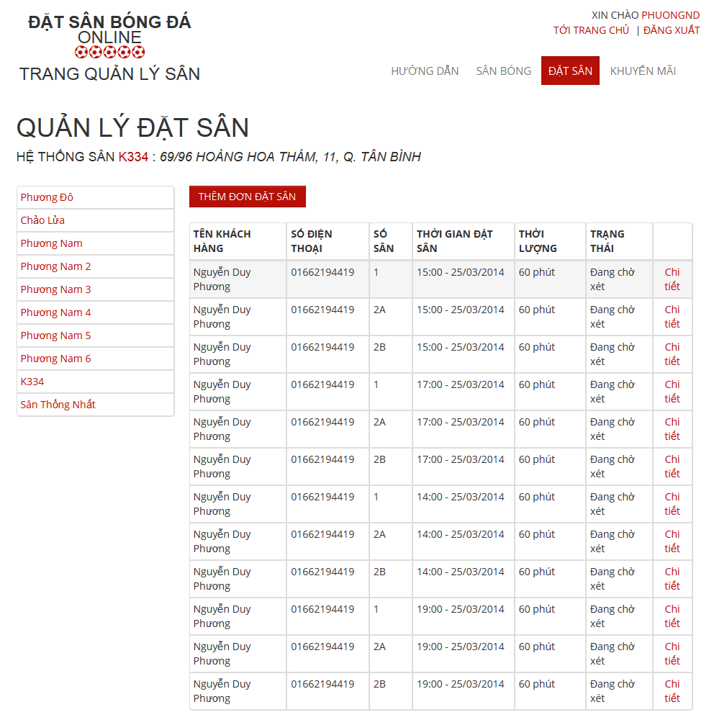

6.2.4.3.2 Add New Reservation

- Step 1 : Click on “ Thêm Đơn Đặt Sân “ button in “ Quản Lý Đặt Sân “ page

- Step 2: Input in all required fields

- Step 3: Click on “ Lưu” button to add new price list or click “ Hủy Bỏ “ button to cancel

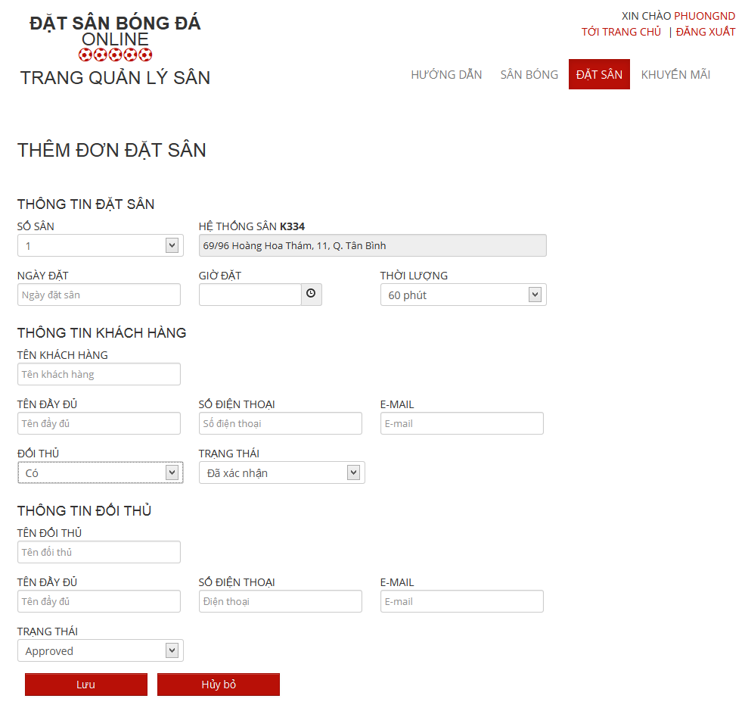

6.2.4.3.3 Confirm Reservation

- Step 1 : Click on “ Chi tiết “ link of the reservation which you want to examine

- Step 2 : Click on “Xác Nhận” button to confirm or click on “Từ Chối” to deny or Click on “ Chỉnh Sửa “ to edit reservation or click on “ Quay Lại “ to cancel

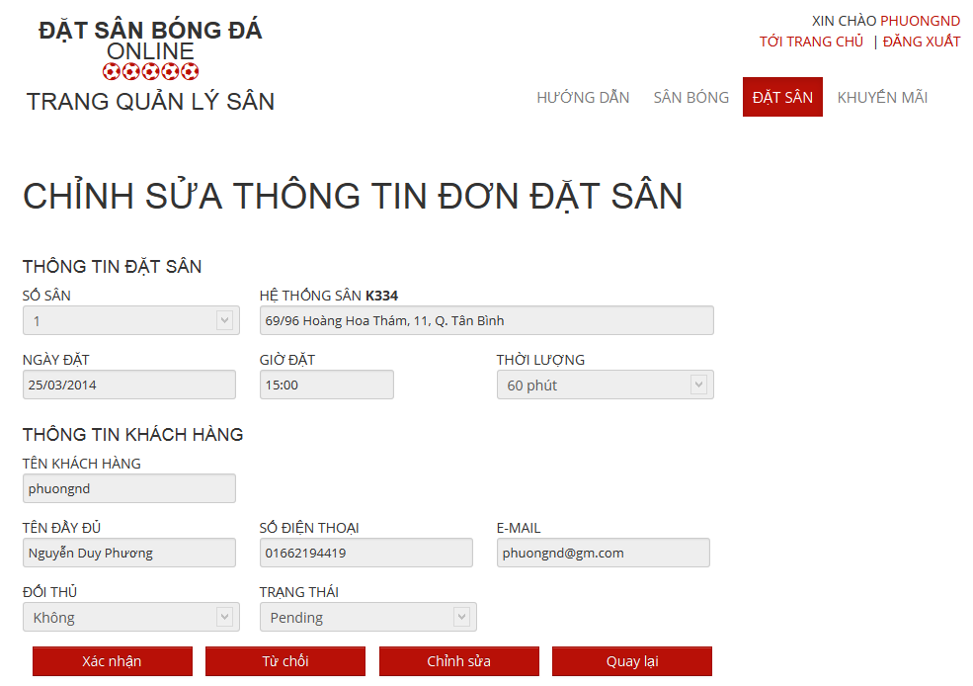

6.2.4.3.4.1 Edit Reservation

- Step 1 : Click on “ Chỉnh Sửa “ button to edit reservation which you want to change

- Step 2: Change information about that reservation

- Step 3: Click on “Lưu” button to save or click “Quay Lại” to cancel

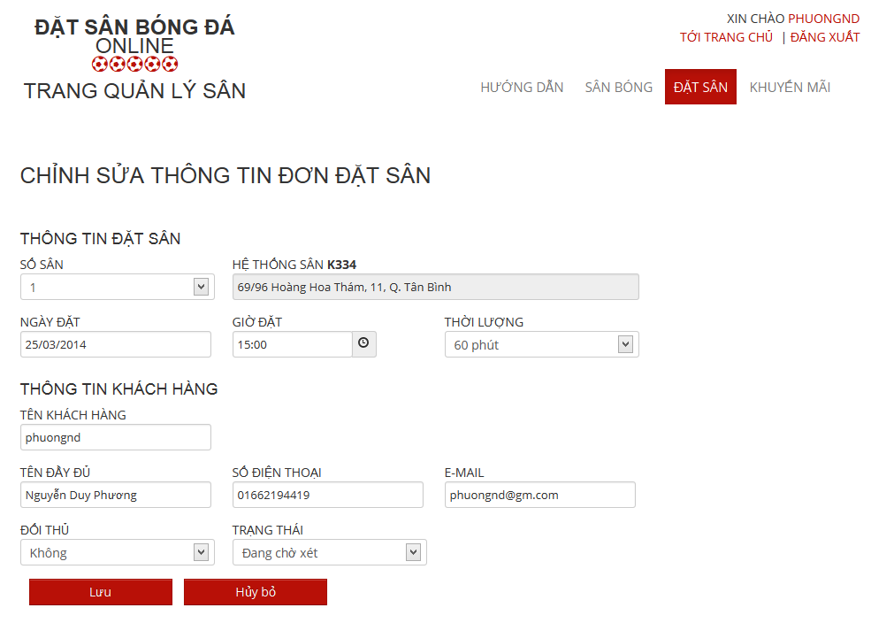

6.2.5 User

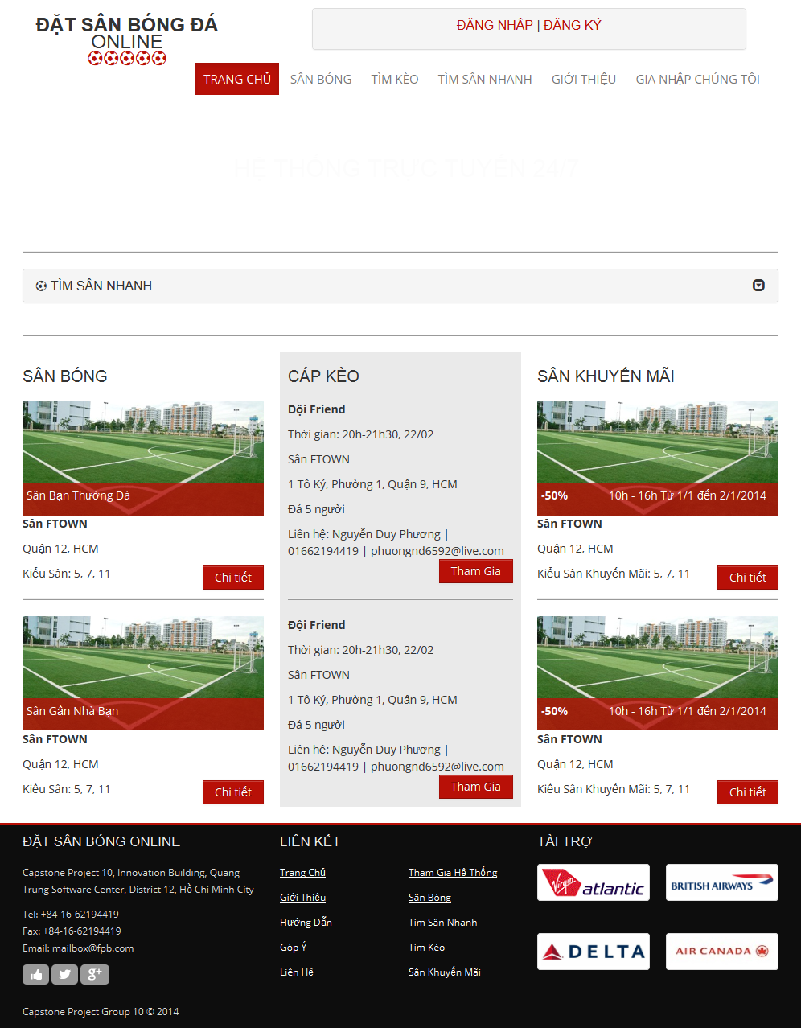

6.2.5.1. Register

- Step 1: Click on “Đăng ký” link on home page.

- Step 2: Input all required field

- Step 3: Click on “Đăng ký” button to register, or click “ Hủy Bỏ “ button to cancel

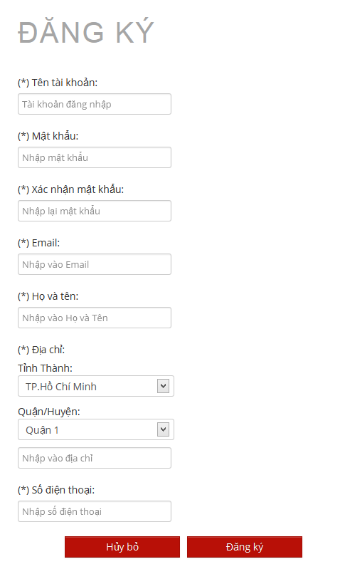

6.2.5.2. Login

- Step 1: Click on “Đăng nhập” link on home page

- Step 2: Input username and password

- Step 3: Click on “Đăng nhập” button

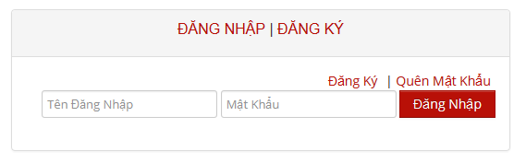

6.2.5.3. View Account Profiles

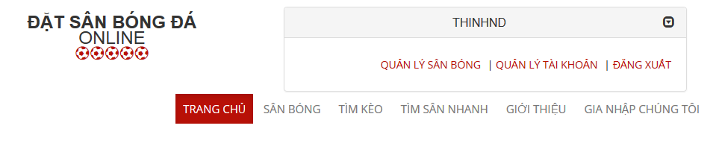

* Step 1: Click on username link to open management window
* Step 2: Click on “Quản lý tài khoản” link

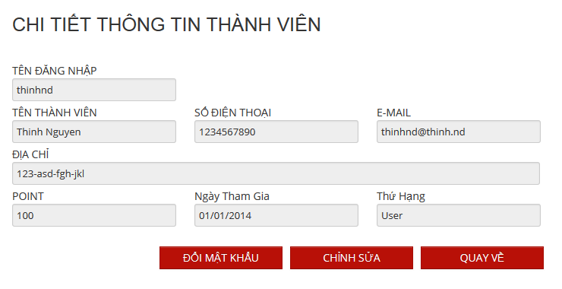

6.2.5.4. Edit Account Profiles

Edit Account Profiles

- Step 1: Click on “Chỉnh sửa” button from view account profiles page

- Step 2: Change account profiles information

- Step 3: Click on “Lưu” to save or click “Quay Lại” to cancel and back to view account profiles page

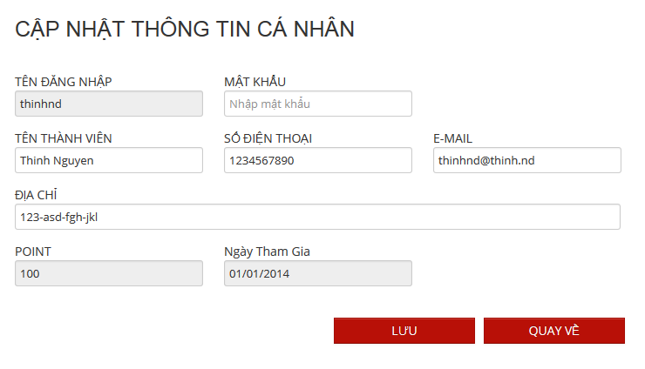

Change Password:

* Step 1: Click on “Đổi mật khẩu” button from view account profiles page
* Step 2: Input old and new password, confirm password
* Step 3: Click on “Lưu” button to save new password or click “ Hủy Bỏ “ button to cancel and back to view account profiles page

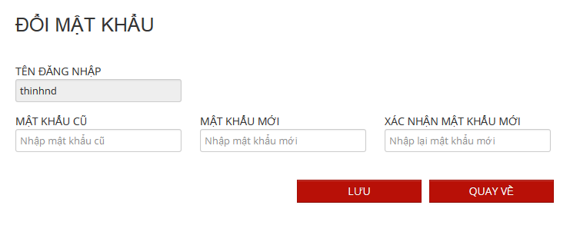

6.2.5.5. Find Available Stadium

- Step 1: Click on “Tìm sân nhanh” link or open “Tìm sân nhanh” board at home page

- Step 2: Choose information

- Step 3: Click on “Tìm kiếm” to find available stadium

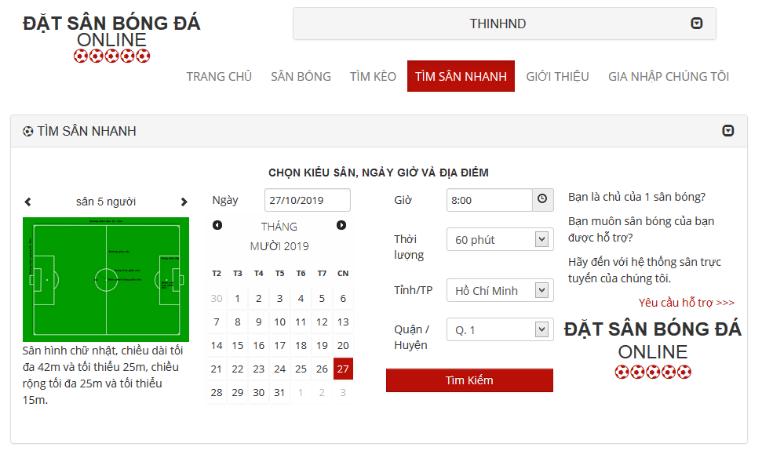

6.2.5.6. Find Stadium

- Step 1 : Click on “ Tìm Sân Nhanh “ link in Homepage

- Step 2 : Input all information about the stadium you want to find

- Step 3 : Click on “ Tìm Kiếm “ button to find

6.2.5.7. View Stadium Details

- Step 1 : Click on “ Sân Bóng “ link in Homepage

- Step 2 : Click on a stadium you want to view information

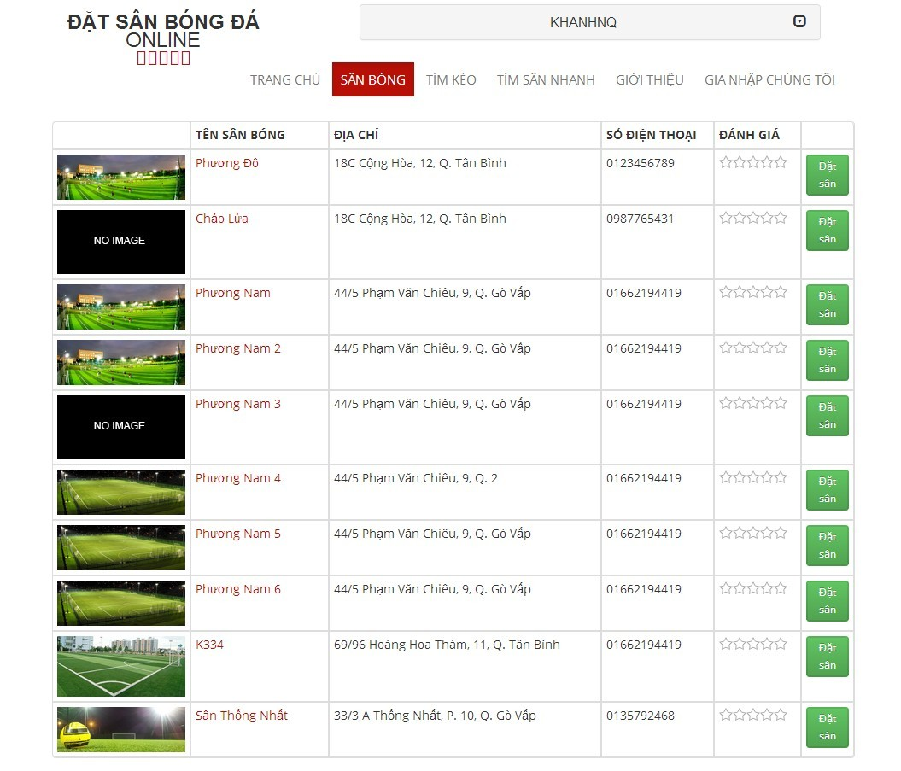

6.2.5.8. Rating Stadium

- Step 1 : Click on “ Sân Bóng “ link in Homepage

- Step 2 : Click on a stadium which you want to rating

- Step 3 : Click on 1 – 5 star for rating stadium

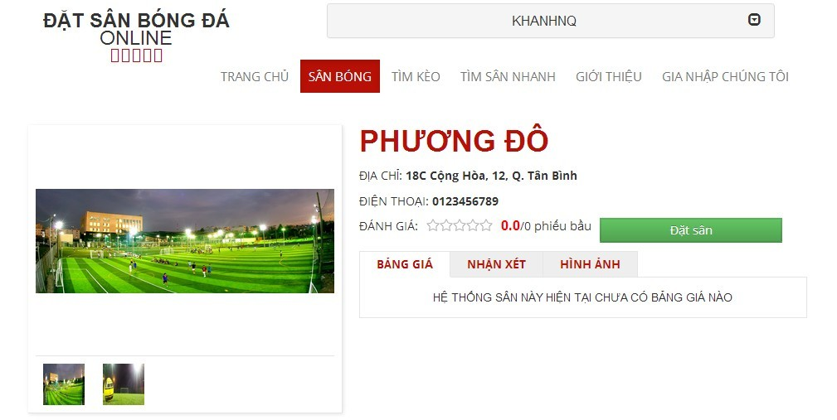

6.2.3.9. Review Stadium

- Step 1 : Click on “ Sân Bóng “ link in Homepage

- Step 2 : Click on the stadium you want to review information

- Step 3 : Click on 3 Tabs : “ Bảng Giá “, “ Nhận Xét “ , “ Hình Ảnh “

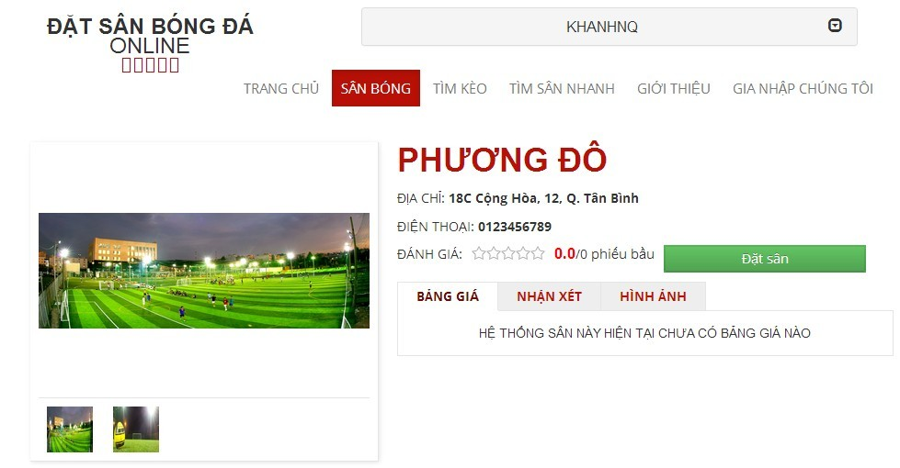

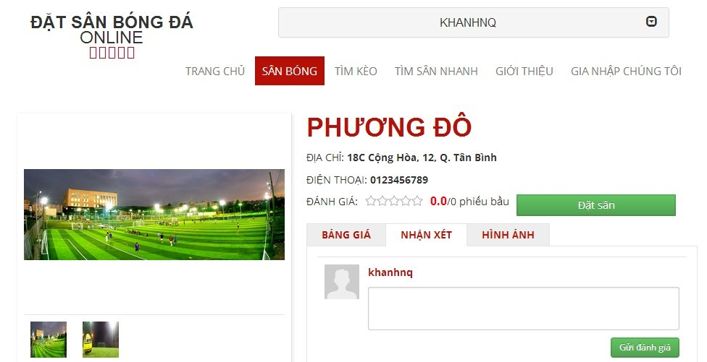

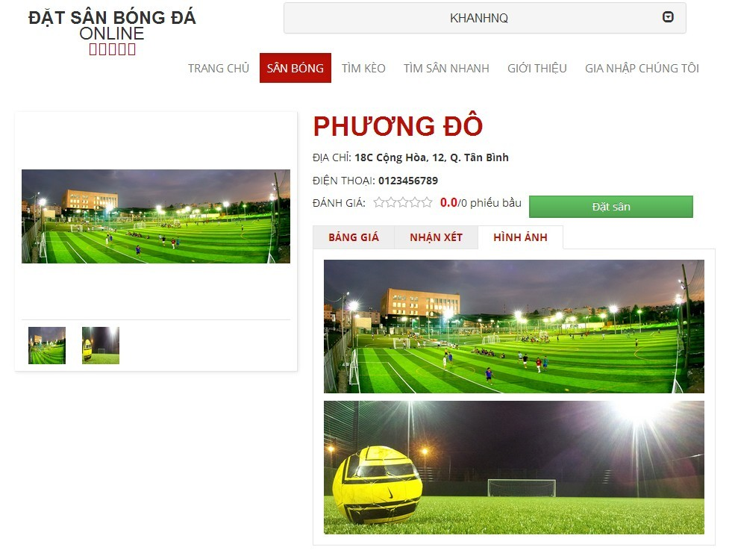

6.2.3.10. Booking Pitches

- Step 1 : Click on “ Sân Bóng “ link in Homepage

- Step 2 : Click on “ Đặt Sân “ button on the stadium you want to book or click on the stadium which you want to book and click on “ Đặt Sân “ button

- Step 3 : Input all require information about stadium you want to book

- Step 4 : Click on “ Đặt Sân “ button to book stadium or “ Hủy Bỏ “ button to cancel or “ Cập Nhật “ to edit “ Thông Tin Cập Nhật “

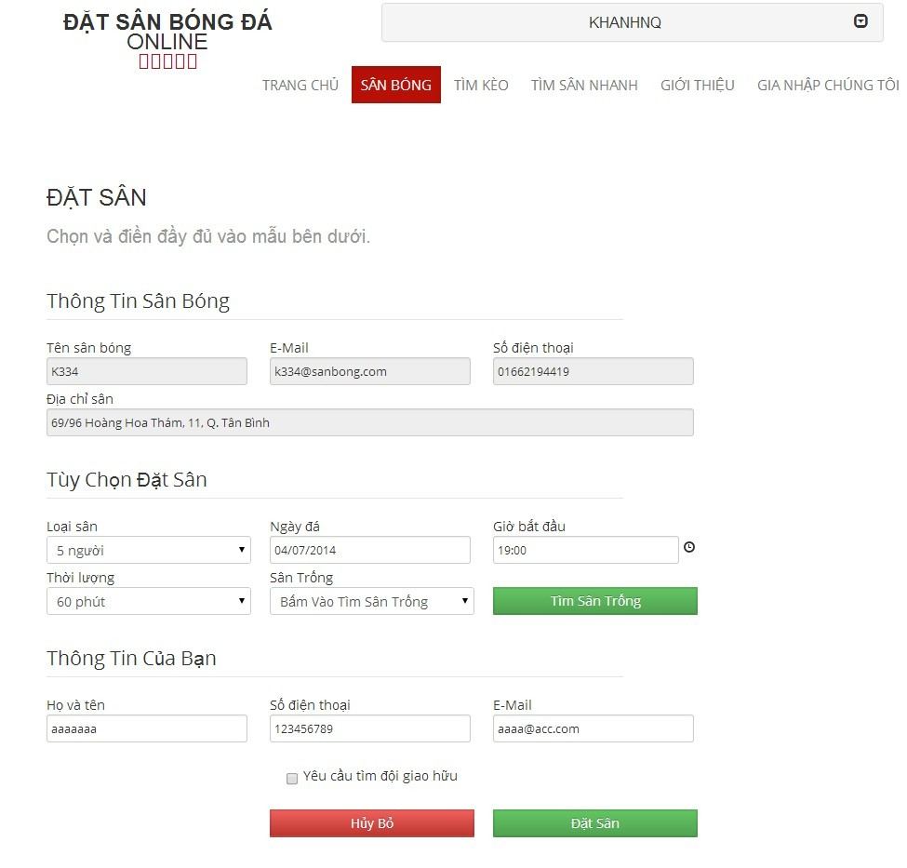

6.2.3.11. Cancel Reservation

- Step 1 : Click on your account

- Step 2 : Click on “ Lịch Sử Đặt Sân “ link

- Step 3 : Click on “ Chỉnh sửa “ link on the stadium which you want to cancel reservation

- Step 4 : Click on “ Hủy Đặt Sân “ button to cancel reservation

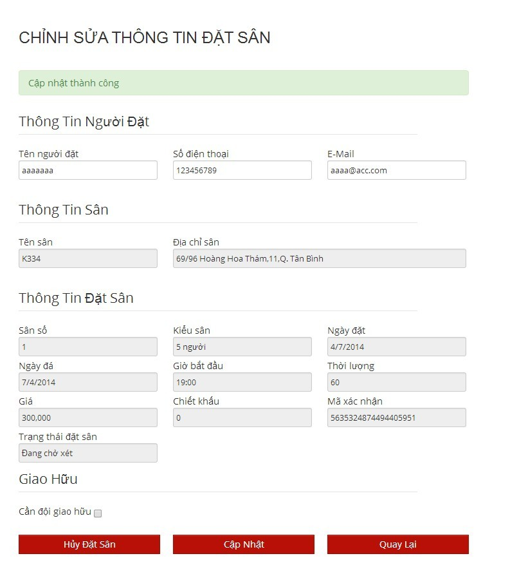

6.2.3.12. Find Rival

- Step 1 : Click on “ Tìm Kèo “ link in Homepage

- Step 2 : Click on team you want to fight or view information

6.2.3.13. Join Rival

- Step 1 : Click on “ Tìm Kèo “ link in Homepage

- Step 2 : Click on team you want to fight or view information

- Step 3 : Click “ Tham Gia “ button

6.2.3.14. View Booking History

- Step 1 : Click on your account

- Step 2 : Click on “ Lịch Sử Đặt Sân “ link to view booking history

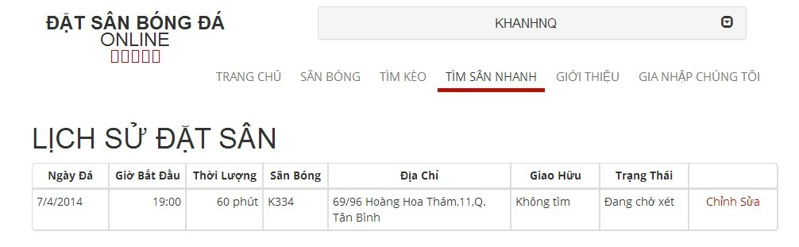

6.2.5.15. Request Join System

- Step 1: Click on “Gia nhập chúng tôi” link from home page

- Step 2: Input all require information

- Step 3: Click on “Gửi yêu cầu” link to send this request or click “Trang chủ” link to back to home page

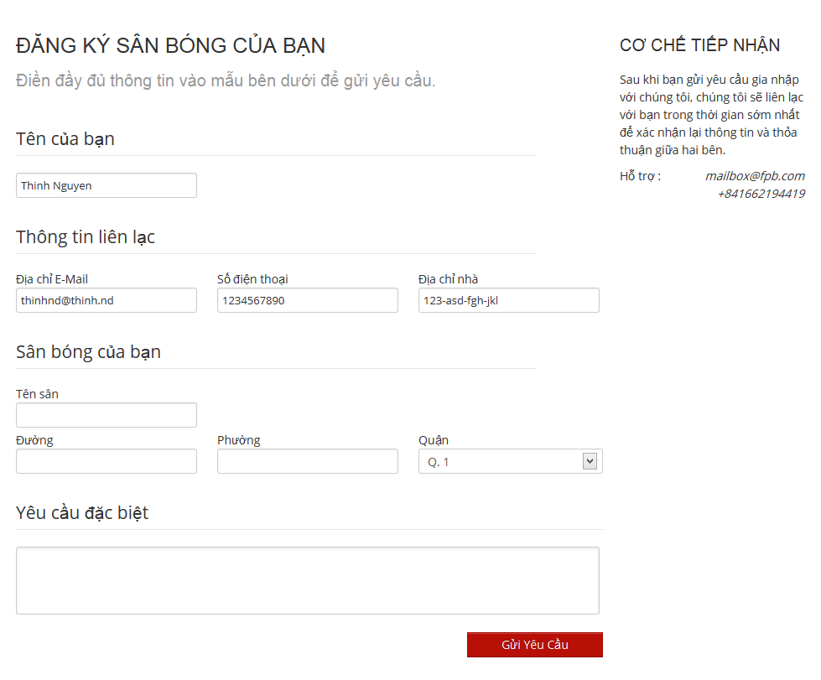

6.2.5.16. Feedback Website   
nó nằm ở mục nào vậy   


##### 6.3. Other [Optional]